Partner AW Reseller Info Sheet


ISD has created a Partner Appraisal Wizard™ (AW) Reseller program. ISD provides Partners and Lead Appraisers with free use of a full AW package assuming they sell it to their clients.

APPRAISAL WIZARD™
Designed for Lead Appraisers, external and internal auditors, and process improvement teams, our integrated compliance management tool suite provides a comprehensive solution, offering the most effective model-based process improvement tool suite in the industry. The tool suite consists of MODEL WIZARD™, MODEL MAPPER™ and APPRAISAL WIZARD™.
PROGRAM BENEFITS
The Partner Reseller receives:
- Free use the full AW suite
- Technical support
- Training
- Marketing assets
- Proposal support
- Commissions on sales. Minimum 10%, up to 25%

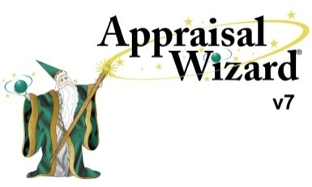
ISD OBLIGATIONS
ISD is required to:
- Provide one full AW suite
- Provide on-going technical support
- Provide start up training
- Provide marketing assets and periodic webinars
- Provide proposal support if requested
- Sign Partner and/or Client NDAs as requested

PARTNER OBLIGATIONS
The partner is required to:
- Bid AW on selected client engagements
- Make at least one AW sale in a 2-year period
- Attend required AW training
- Attend periodic AW webinars

